Here is the dataset of a store, which has branches all over the world. The stakeholders require the detailed report on their sale transaction.

* Perform the basic data cleaning (Score: 2)
* Segment the visuals using country, region, market (Score: 1)
* Analyze the data by visualizing the percentage of shipping based on ship mode.(Score:1)
* Give the report to see sales over the city, states, region and market. (Score: 1)
* Create tables for all the visualizations. (Score: 1)

Make these visualizations and create an interactive sales report to show the stakeholders.

Create a video explaining the visualizations.

1 FIGURE

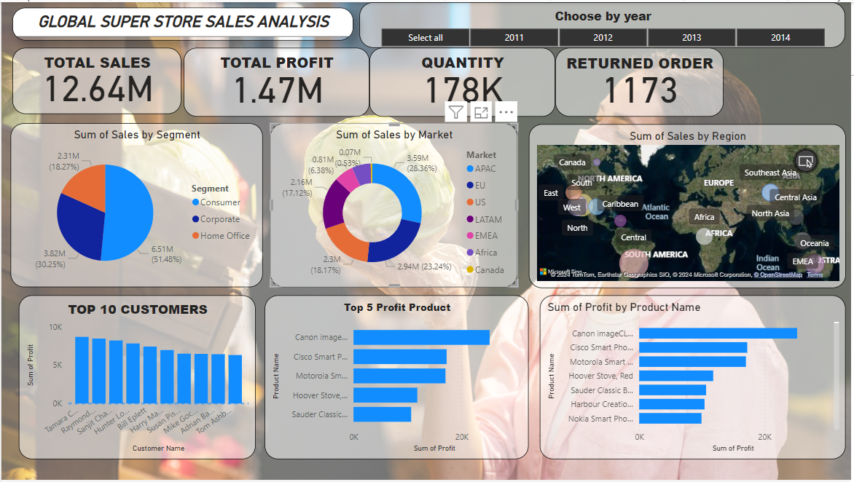

2FIGURE

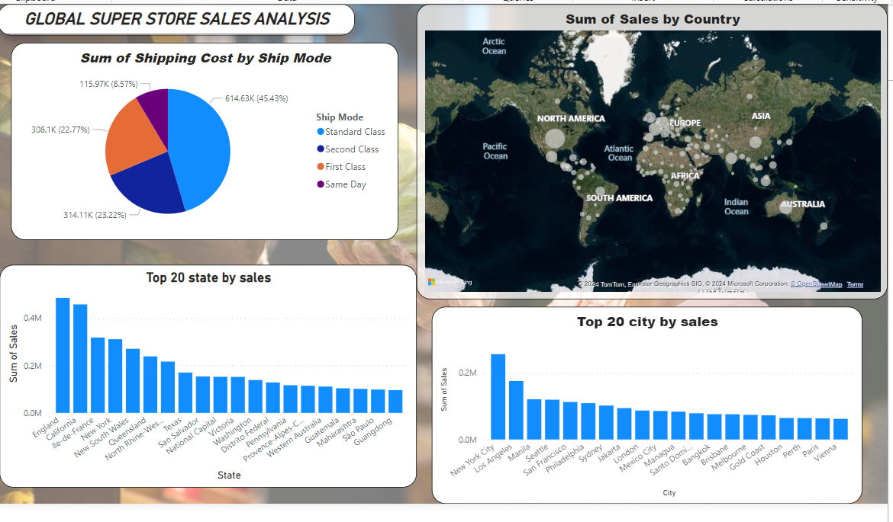

3 FIGURE

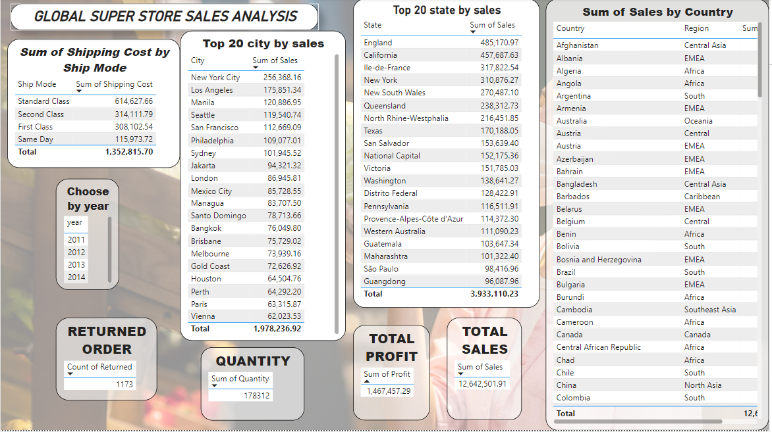

4 FIGURE